**Name: Elijah Japeth O. Ramos**

**1-5**

1. Display all columns from tbl_employees.

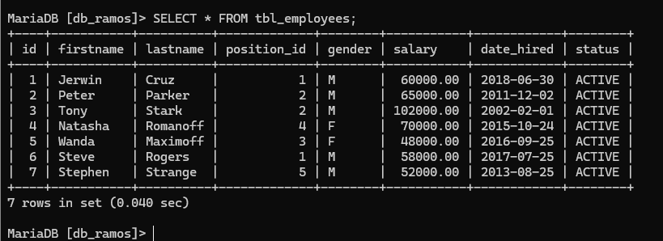

1. Display only the firstname and lastname of all employees.

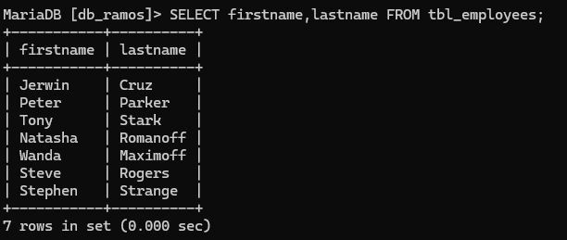

1. Show firstname, lastname, and salary of all employees.

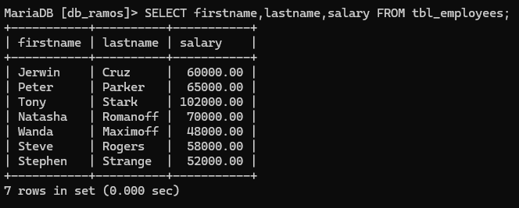

1. Find all employees whose firstname starts with **'S'**.

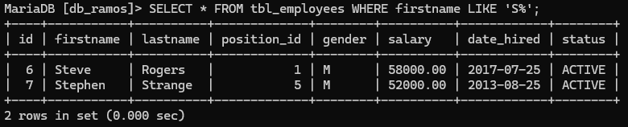

1. Find all employees whose lastname ends with **'off'**.

